Ann Voskamp’s Emergent Roots.

Ann Voskamp’s Best Selling Book One Thousand Gifts – A Collision of Inspiration and the New Spirituality
June 19th, 2011 | Author: Lighthouse Trails Editors
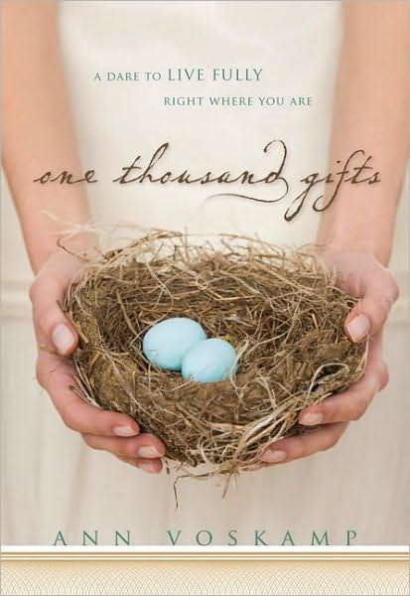
Ann Voskamp also endorses the use of Lectio Divina, a form of Mystic prayer referenced in another article.
One Thousand Gifts by Ann Voskamp is a 2010 Zondervan title that is a New York Times, USA Today, and Amazon Best-Seller. The author is a contributing writer for DaySpring, and she has a blog that receives 40-50 thousand visitors every week.1 Voskamp has risen quickly in popularity, with invitations to various conferences and other events. (In April, she spoke in Portland Oregon at the Q Conference sharing a platform with popular Christian figures like Luis Palau and Louie Giglio).
Ann Voskamp’s sincerity and her desire for a relationship with the Lord are unarguable. Her honesty in her own shortcomings and frailties is admirable. Her description of how she witnessed the death of her baby sister (run over by a farm truck) when she herself was very young is heart-wrenching. What’s more, few would disagree with the overall key theme of the book that we should give thanks to God in everything (1 Thessalonians 5:18). Voskamp shares how practicing thanksgiving and gratitude has changed her life. Thinking about 1 Timothy 6:6 (“godliness with contentment is great gain”), it is true that being thankful and content does have great gain in the believers life.
But One Thousand Gifts, as well-meaning as the author may be, is not a book we can recommend and in fact is one we must warn about. We do not want to cause distress to Ann Voskamp; but given the high popularity of her book, we are compelled to issue this warning.
It is clear by reading One Thousand Gifts that Ann Voskamp reads and admires several mystics, panentheists, and universalists. Her book is peppered with quotes by Sarah Ban Breathnach (a New Age author launched into stardom by Oprah),https://www.bing.com/videos/search?q=Sarah+Ban+Breathnach&view=detail&mid=530F186D6CF892A791A5530F186D6CF892A791A5&FORM=VIRE Teresa of Avila, Julian of Norwich, Evelyn Underhill, Brennan Manning, Annie Dillard, Thomas Acquinas, Buddhist sympathizer and Catholic convert Peter Kreeft, Walter Brueggemann, Francis de Sales, Jesuit priest Pierre Teilhard de Chardin, Henri Nouwen, and Jean-Pierre de Caussade. Many of the statements Voskamp says in her book would resonate with these authors showing that Voskamp has absorbed some of the beliefs of these people. In addition, Voskamp’s popular blog lists a number of contemplative/emerging authors on her book list page: Richard Foster (Celebration of Discipline), Adele Ahlberg Calhoun (Spiritual Disciplines Handbook, a primer on Eastern style meditation), and emerging church author Phyllis Tickle are included.
In reading One Thousand Gifts, we are reminded of author Sue Monk Kidd (The Secret Life of Bees), who started off as a conservative Southern Baptist Sunday School teacher, but when she began reading Thomas Merton and other mystical writers, her spiritual outlook changed dramatically. The progress of Monk Kidd’s spiritual change can be seen from one book to the next. Today, she is a self-proclaimed worshipper of the goddess Sophia and states in her book The Dance of the Dissident Daughter that God is in all things (panentheism) even graffiti and excrement. Monk Kidd says:
Deity means that divinity will no longer be only heavenly … It will also be right here, right now, in me, in the earth, in this river, in excrement and roses alike. (p. 160)
Ann Voskamp echoes Monk Kidd when she states that God is “present in all things,” even “sewage flowing downriver” (p. 110-111)
The last chapter of One Thousand Gifts, “The Joy of Intimacy,” Voskamp devotes to what she calls “intimacy” with God. But brace yourself, you won’t find the way she talks about intimacy with God in the Bible. We share the following with you not to shock you for theatrical sake – its to show where the “new” Christianity is heading. We think it important, in light of the many young women who are reading this book, to quote Voskamp’s view of “intimacy” with God which she also calls the “mystery of that romance.” Voskamp says:
Mystical union. This, the highest degree of importance. God as Husband in sacred wedlock, bound together, body and soul, fed by His body, quenched by His blood . . . God, He has blessed – caressed. I could bless God – caress with thanks. It’s our making love. God makes love with grace upon grace, every moment a making of His love for us. . . . couldn’t I make love to God, making every moment love for Him? To know Him the way Adam knew Eve. Spirit skin to spirit skin. . . The intercourse of soul with God is the very climax of joy . . . To enter into Christ and Christ enter into us – to cohabit. (pp. 213, 216-217).
We find Voskamp’s mixture of sexual and spiritual language when referring to a relationship with God offensive. The most “intimate” relationship anyone ever had with God on this earth was the one Jesus Christ had with His Father; but nowhere in the Bible does Jesus (or the disciples) use sexual language and innuendos to describe the relationship between God and man. And in fact, the Bible tells us that sexual union was given to man, in the confines of marriage between a man and wife, for procreation; the Bible also tells us that in our eternal heavenly home, there will be no marriage (the need for procreation will not exist). If we, as Christians, were supposed to think about our relationship with God in sexual terms, wouldn’t God have made that clear in His word? It’s like the contemplative prayer movement that emphasizes repeating a word or phrase over and over to be intimate with God. But nowhere are we instructed to do this in Scripture. It’s as if the Holy Spirit who inspired men to write the books of the Bible left out vital elements that now contemplatives and emergents are enlightening us to. God forbid that we should think so. Books like One Thousand Gifts have added to what God has said in His Word.
Voskamp isn’t the only emerging-type author to use sexual language when talking about intimacy with God. We see an increase in books and speakers talking about” intimacy with God” (most of these writers are proponents of contemplative – that’s no coincidence – but rather signs that tantra spirituality (sexual experiences combined with mystical experiences)) is entering the church now. One of the most popular books today on marriage, Sacred Marriage by Gary Thomas (promoted by Calvary Chapel, Focus on the Family, and Rick Warren) is laced with quotes by or references to (about a dozen instances) Mary Anne McPherson Oliver’s book, Conjugal Spirituality, a primer on tantric sex; McPherson Oliver says that “mystical experiences can be associated with erotic love.” McPherson Oliver tells readers to use mantras and breath prayers during the sexual experience to help induce the tantric mystical experience. The fact that one of today’s most popular Christian books on marriage has so many references to this book is a telling sign of what has entered the evangelical/Protestant church. The popularity of One Thousand Gifts is another sure indication.
Today, the “new” progressive Christianity is more sensual than spiritual. Appealing to the senses (making it sensual) and the carnal man rather than strengthening the spiritual man within. Scripture warns us though: “For to be carnally minded is death; but to be spiritually minded is life and peace” (Romans 8:6). One Thousand Gifts may be the poster book, so to speak, for the latest carnally-minded book, taking a place in line with The Shack.
For an in-depth review of One Thousand Gifts, please read Bob DeWaay’s review titled: http://www.lighthousetrailsresearch.com/blog/?p=6614

