Purge the Bigots
By William Saletan
Brendan Eich is just the beginning. Let’s oust everyone who donated to the campaign against gay marriage.

Eich is gone. The creator of JavaScript and co-founder of mozilla.org has quit as Mozilla’s CEO, forced out by the uproar over a donation he made six years ago to a ballot measure against gay marriage. There’s no record of Eich discriminating against gay employees—“I never saw any kind of behavior or attitude from him that was not in line with Mozilla’s values of inclusiveness,” says the company’s chairwoman, Mitchell Baker. In fact, last week, Eich pledged,
I am committed to ensuring that Mozilla is, and will remain, a place that includes and supports everyone, regardless of sexual orientation, gender identity, age, race, ethnicity, economic status, or religion.

You will see exemplary behavior from me toward everyone in our community, no matter who they are; and the same toward all those whom we hope will join, and for those who use our products. Mozilla’s inclusive health benefits policies will not regress in any way. And I will not tolerate behavior among community members that violates our Community Participation Guidelines or (for employees) our inclusive and non-discriminatory employment policies.
William Saletan

But that wasn’t enough. A revolt among Mozilla staffers, compounded by pressure from software developers, outrage on Twitter and a boycott movement spearheaded by OkCupid, has driven Eich out. Baker, having accepted Eich’s resignation, offers this apology: “We know why people are hurt and angry, and they are right: it’s because we haven’t stayed true to ourselves.”
Some of my colleagues are celebrating. They call Eich a bigot who got what he deserved. I agree. But let’s not stop here. If we’re serious about enforcing the new standard, thousands of other employees who donated to the same anti-gay ballot measure must be punished.

More than 35,000 people gave money to the campaign for Proposition 8, the 2008 ballot measure that declared, “Only marriage between a man and a woman is valid or recognized in California.” You can download the entire list, via the Los Angeles Times, as a compressed spreadsheet. (Click the link that says, “Download CSV.”) Each row lists the donor’s employer. If you organize the data by company, you can add up the total number of donors and dollars that came from people associated with that company.

The first thing you’ll notice, if you search for Eich, is that he’s the only Mozilla employee who gave to the campaign for Prop 8. His $1,000 was more than canceled out by three Mozilla employees who donated to the other side.
The next thing you’ll notice is that other companies, including other tech firms, substantially outscored Mozilla in pro-Prop 8 contributions attributed to their employees. That includes Adobe, Apple, Google, Microsoft, Oracle, Sun Microsystems, and Yahoo, as well as Disney, DreamWorks, Gap, and Warner Bros.

Thirty-seven companies in the database are linked to more than 1,300 employees who gave nearly $1 million in combined contributions to the campaign for Prop 8. Twenty-five tech companies are linked to 435 employees who gave more than $300,000. Many of these employees gave $1,000 apiece, if not more. Some, like Eich, are probably senior executives.
Why do these bigots still have jobs? Let’s go get them.
To organize the next stage of the purge, I’ve compiled the financial data into three tables. Here’s the first table. It shows 37 companies whose names, in one form or another, appear next to a total of at least $10,000 (per company) in donations to Prop 8. The list isn’t complete, but it’s a start.
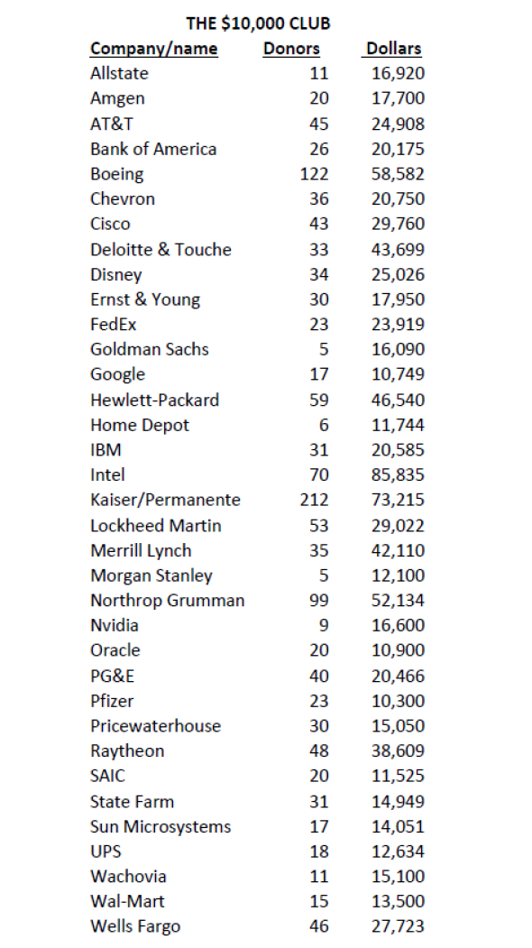
The next table, below, shows 25 tech companies whose employees donated to the campaign for Prop 8. Again, the list isn’t exhaustive. But every one of these companies outscored Mozilla in associated contributions to Prop 8.
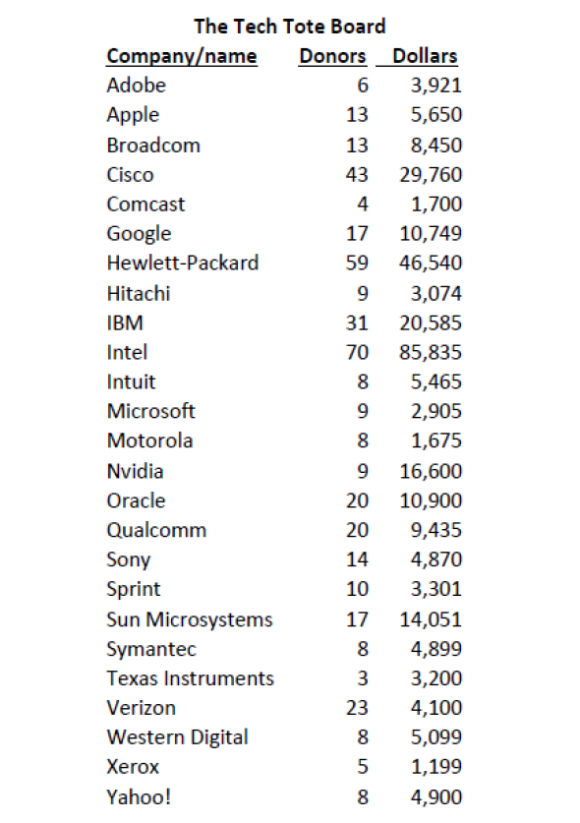
The last table, below, shows several other companies that didn’t hit the $10,000 threshold but did surpass Mozilla in money for Prop 8. Some of them might surprise you.
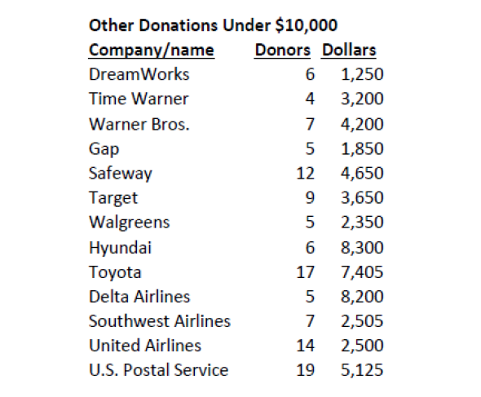
The numbers in these tables don’t represent contributions from the companies. (All the money came from individuals.) Nor do they reflect the balance of contributions that came from a company’s employees. (I haven’t added up the donations that went to the campaign against Prop 8.) A quick glance here and there suggests that in many cases, the balance of contributions from these companies went against the ballot measure.

But why stop there? If we’re serious about taking down corporate officers who supported Proposition 8, and boycotting employers who promote them, we'd better get cracking on the rest of the list. Otherwise, perhaps we should put down the pitchforks.
Also in Slate:
The Astonishing Conservative Hypocrisy Over Mozilla and the First Amendment
We Shouldn’t Forgive Brendan Eich for His Homophobic Past—Yet If You're Against Gay Marriage, You're a Bad CEO

