Christians React to the Legalization of Same-Sex Marriage: Key Findings

Barna Research Group
https://www.barna.org/barna-update/culture/723-christians-react-to-the-legalization-of-same-sex-marriage-9-key-findings#.VZRzjsLnb-c
July 1, 2015—— On June 26, 2015, the U.S. Supreme Court ruled to legalize same-sex marriage in all 50 states. This landmark decision was met with both celebration and sorrow as Americans on both sides of the debate voiced their opinions on the decision. A new Barna survey conducted in the wake of the ruling reveals nine key findings that will help make sense of where Americans stand—and what’s next in this divisive conversation.
1. Americans remain deeply divided on the issue.
While there are plenty of demographic groups that lean heavily in one direction or the other, the general population remains divided in their support of legal same-sex marriage. About half of the general population supports the recent Supreme Court decision (49%). Just over four in 10 Americans disagree with the decision (43%) and 7 percent say they don’t know how they feel about it. Americans are split, as well, on whether legalized same-sex marriage will have a positive (37%) or negative impact (40%) on society. Divisions also emerge when it comes to whether legalizing same-sex marriage is morally right (52%) or morally wrong (43%). And similar proportions of Americans believe same-sex marriage is protected by the Constitution (52%) or say it is unconstitutional (38%).
2. However, most agree that legal same-sex marriage was inevitable.
Americans may be divided on how they feel about the decision, but most perceived the decision to be only a matter of time. Six in 10 Americans say legalization was an inevitability (62%). Evangelicals*—a group Barna defines according to their stance on a number of theological beliefs, outlined below—remain an exception: Just three in 10 say same-sex marriage was a foregone conclusion (31%), half that of the general population. Interestingly, a slim majority of Americans reject the idea that the same-sex marriage movement could accurately be compared to the Civil Rights movement of the 1960s (55%).
3. Practicing faith is a stronger indicator than religious identity.
In addition to self-identified religious and denominational identity—Christian, Jewish, Muslim, Mainline, Catholic and so on—Barna Group categorizes respondents into various belief and faith practice segments. Looking at these variances within belief systems, Barna can identify ways in which those who are more personally observant of their faith differ from those who are “legacy” or “cultural” believers. These differences often tend to be significant, and the new findings are no exception. Christians who qualify as “practicing”—those who say their faith is very important to their life and who have attended one or more church services during the past month—differ significantly in their stance toward same-sex marriage from those who self-identify as Christian but do not regularly attend church or prioritize their faith. In this instance, practicing Christians (28%) are far less likely than self-identified Christians (43%) to favor the Supreme Court ruling.
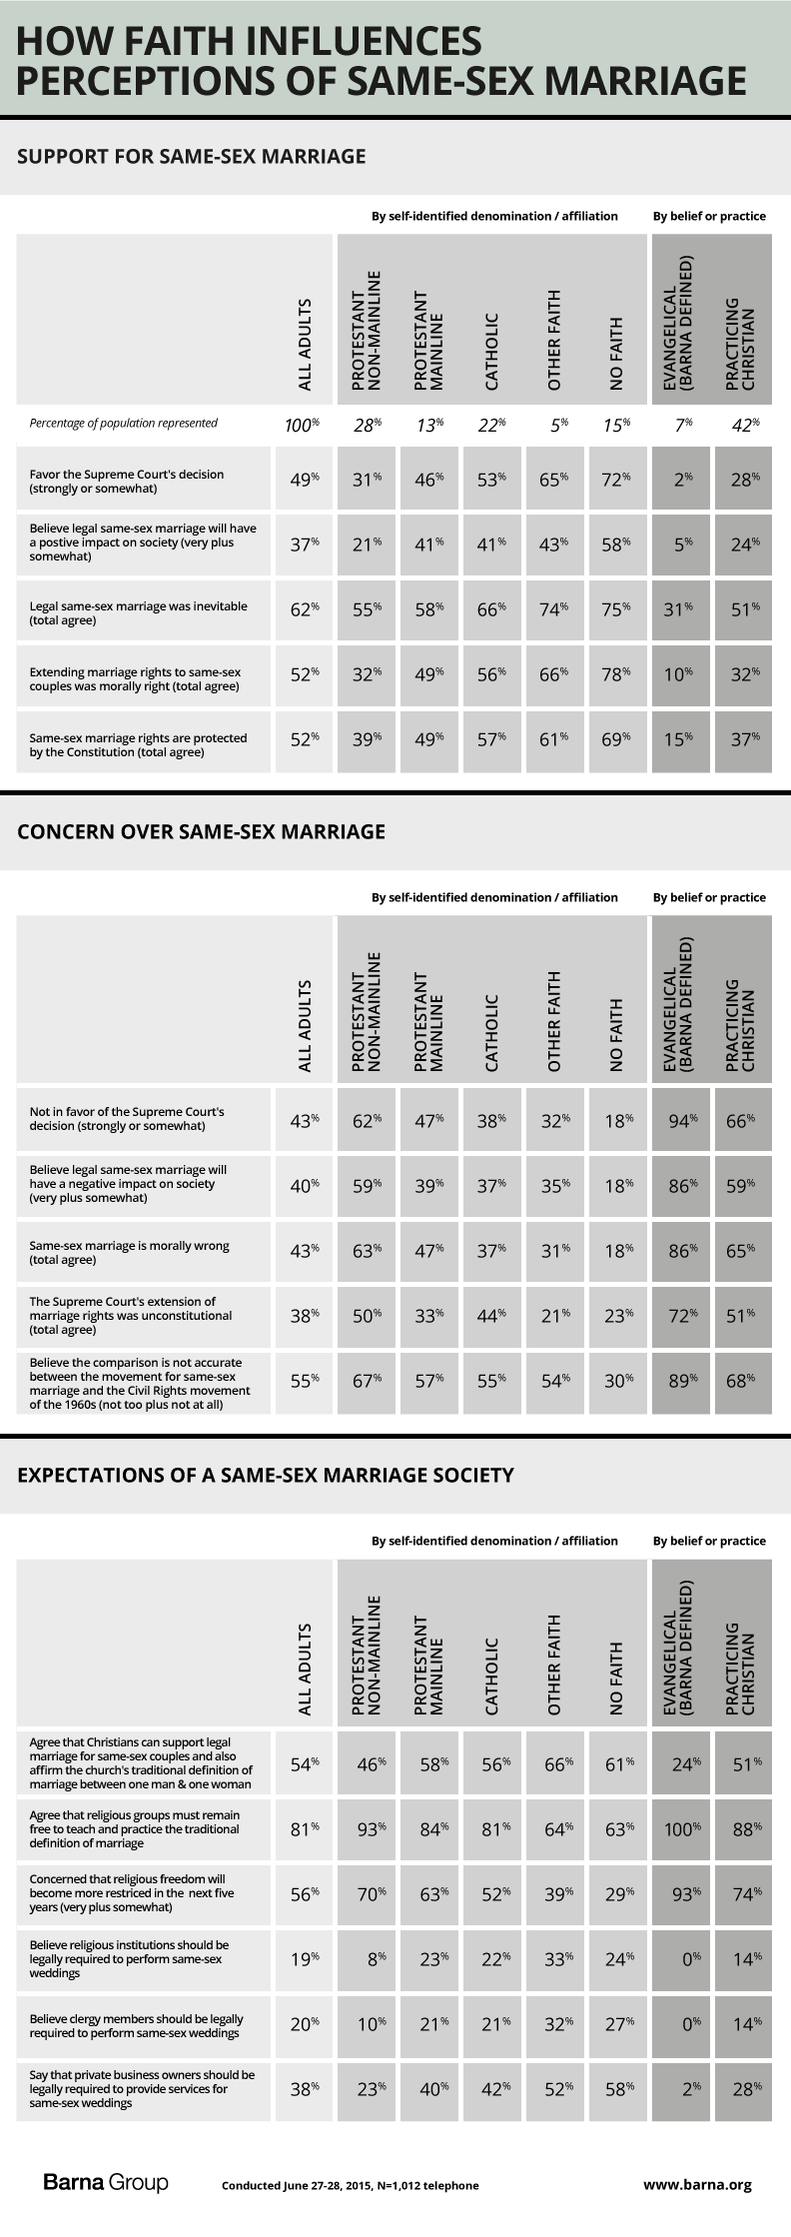
4. Evangelicals*, more than any other faith segment, continue to strongly oppose same-sex marriage.
Beyond faith identity and practice, Barna also defines some Christian groups, such as evangelicals, based on their theological convictions. (Most self-described measures of evangelicalism are not reliable; Barna’s definitions are found below.) Nearly all theologically defined evangelicals say they are not in favor of the Court’s decision (94%)—more than twice the proportion among the general population (43%) and even significantly more than the practicing Christians segment (66%). Only 2 percent of evangelicals say they support the decision to legalize same-sex marriage. They are also much more likely to say same-sex marriage will have a negative impact on society (86% vs. 40% among all U.S. adults), to believe extending marriage rights was morally right (10% vs. 52%) and to say same-sex marriage rights are protected by the Constitution (15% vs. 52%).
5. Younger practicing Christians more closely align with older practicing Christians than with others under 40.
Age has been—and continues to be—a defining fault line on this issue. Younger practicing Christians, however, have more in common with their older counterparts than they do with the general population. One-third of practicing Christians under 40 favor the ruling (35%), compared to six in 10 among all adults in their age cohort (61%)—a gap of 26 percentage points. By comparison, there is only a nine-point gap between younger practicing Christians and those 40 and older (26%). Many Christians have felt divisions in their own tribe over this issue, and nowhere are those divisions more clear than between practicing Christians under 40 and non-practicing Christians in the same age group. On nearly every question, deep divides emerge between these two groups of younger Christians. While only one-third of practicing Christians under age 40 (35%) are in favor of the Supreme Court’s decision, three-quarters of non-practicing Christians of the same age support the decision (73%). The only real agreement comes in the shared belief that Christians can support legal marriage for same-sex couples while also affirming the church’s traditional definition of marriage being between one man and one woman (55% of practicing Christians under 40 vs. 58% of non-practicing Christians under 40).
6. Most people acknowledge a difference between legal same-sex unions and marriages performed by the church.
Similarly, the majority of Americans—including most religious groups—acknowledge this difference between church and state unions. More than half of Americans agree that “Christians can support legal marriage for same-sex couples and also affirm the church’s traditional definition of marriage between one man and one woman” (54%). Only evangelicals (24%) and practicing non-mainline Protestants* 40 and older (41%) are less likely than average to agree.
7. The majority of Americans—regardless of faith or age—believe religious institutions and clergy should not be forced to perform same-sex marriages against their beliefs.
A significant majority of Americans disagree with the argument that religious institutions or clergy should be required to perform same-sex marriages against their beliefs; only one-fifth of Americans (19%) say they should be required to do so. Even among those with no faith, less than one-quarter (24%) argue that such institutions should be required to perform same-sex marriages. There is a substantial minority, however, among Americans under 40 (26%) who believe the law should compel religious institutions and clergy members to perform same-sex weddings.
8. Americans are more divided on whether for-profit businesses should be required to provide services for same-sex weddings.
While Americans feel strongly that religious institutions should be protected against compulsion to perform same-sex weddings, they display more ambivalence toward for-profit enterprises. While a majority of U.S. adults disagrees that for-profit businesses should be legally required to provide services for a same-sex wedding, Americans under 40 (44%) are more likely than the general population (35%) to say businesses should be required to do so. Younger practicing Christians (33%) land between all adults (38%) and older practicing Christians (27%) on this question.
9. Older Americans and conservative faith groups are concerned about the future of religious freedom.
The majority of Americans—nearly six in 10—say they are concerned that religious freedom will become more restricted in the next five years (56%). These concerns are heightened among older Americans: 62 percent of adults over age 40, compared to 45 percent of Americans under 40, say they are concerned about the future of religious freedom. Not surprisingly, those who are religious are most concerned: Three-quarters of practicing Christians 40 and older (77%) and nine out of 10 evangelicals (93%) say they are concerned that religious freedom will become more restricted in the next five years.
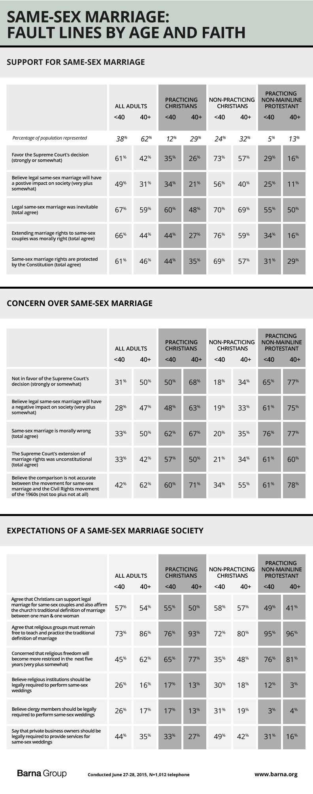
What the Research Means
David Kinnaman, president of Barna Group, directed the study and offered three perspectives on the findings. “First, many practicing Christians—including evangelicals—appear to be looking for ways to express their faith authentically in this cultural context. For one thing, observers should not underestimate the depth of the opposition that evangelicals feel toward same-sex marriage. The 20 million or so Americans who qualify under Barna’s theological rubric are not just sort of different from other groups—they are dramatically different in their ideological and theological resistance. Still, it’s interesting that many Christians, including evangelicals, are coming to the conclusion that it’s possible to support legal same-sex marriage and also affirm the church’s traditional definition of marriage. Many Christians are attempting to negotiate the new normal on this.
“Second, the gap between younger practicing Christians and younger Christians who no longer actively practice their faith is striking,” Kinnaman continues. “Some have speculated that many young people have left church because of the church’s traditional stance on LGBTQ issues. And while this research doesn’t confirm this finding, it certainly shows that inactive Christians are skeptical about a great deal of the Church’s authority on these kinds of matters. The gaps between younger practicing Christians and younger lapsed and dechurched Christians will be a major cultural fault line—particularly as younger churchgoers become a smaller slice of the overall population.
“Third, while it is a minority of Americans who believe clergy should be legally compelled to perform same-sex marriages, one in five is not an insignificant number. And two in every five Americans contend that businesses should be made to provide services to same-sex marriages. These represent points of view that—given their prevalence among younger Americans—could represent shifts in how Christians are able to exercise their religious freedoms.”
Comment on this research and follow our work:
Twitter: @davidkinnaman | @roxyleestone | @barnagroup
Facebook: Barna Group
*Definitions
Evangelicals are defined in this survey as people who meet nine belief conditions. These include saying they have made “a personal commitment to Jesus Christ that is still important in their life today,” that their faith is very important in their life today; believing that when they die they will go to Heaven because they have confessed their sins and accepted Jesus Christ as their Savior; believing they have a personal responsibility to share their religious beliefs about Christ with non-Christians; believing that Satan exists; believing that eternal salvation is possible only through grace, not works; believing that Jesus Christ lived a sinless life on earth; asserting that the Bible is accurate in all the principles it teaches; and describing God as the all-knowing, all-powerful, perfect deity who created the universe and still rules it today. Being classified as an evangelical is not dependent on church attendance, the denominational affiliation of the church attended or self-identification. Respondents were not asked to describe themselves as “evangelical.”
Practicing Christians are self-identified Christians who say their faith is very important to their lives and who have attended a worship service, other than for a special occasion, one or more times during the past month.
Non-practicing Christians are self-identified Christians who do not qualify as “practicing” under the criteria above.
Practicing non-mainline Protestants are self-identified Christians who qualify as “practicing” under the criteria above and report affiliation with a Protestant church that is not mainline. These include Adventist (Seventh-Day or other); A.M.E.; Assemblies of God; Southern Baptist; other Baptist (other than ABCUSA); Churches of Christ (other than UCC); Churches of God; Disciples of Christ; Evangelical (Free; Covenant); Foursquare; Lutheran (Missouri Synod; WELS); Mennonite; Nazarene; Non-denominational/independent; Pentecostal; Presbyterian (other than PCUSA); Reformed; Wesleyan.
Practicing mainline Protestants are self-identified Christians who qualify as “practicing” under the criteria above and report affiliation with a Protestant church that is mainline, including American Baptist Churches; the Episcopal Church; Evangelical Lutheran Church of America; United Church of Christ; United Methodist Church; and Presbyterian Church, USA.

About the Research
This research contains data from a survey of 1,012 U.S. adults ages 18 and older conducted June 27-28, 2015.
The survey was taken using random digit-dial telephone samples for landlines and listed cell phone samples for calls to mobile phones. The sampling error for this study is plus or minus 3.1 percentage points at the 95-percent confidence level. The number of interviews completed with cell-phone owners was based on federal government estimates of the number of cell-only households.
Minimal statistical weighting was used to align the sample with known population demographics.
About Barna Group
Barna Group (which includes its research division, Barna Research Group) is a private, non-partisan, for-profit organization under the umbrella of the Issachar Companies. Located in Ventura, California, Barna Group has been conducting and analyzing primary research to understand cultural trends related to values, beliefs, attitudes and behaviors since 1984.
If you would like to receive free e-mail notification of the release of each update on the latest research findings from Barna Group, you may subscribe to this free service at the Barna website (www.barna.org).
© 2015 by Barna Group.

